Birthday menu

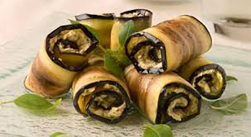
Cold Starters:
Eggplant rolls with walnuts
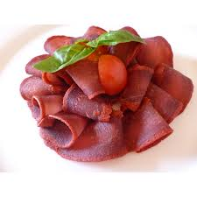
Basturma

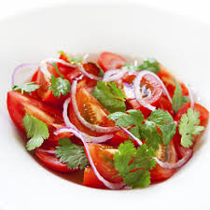
Salads :
Baku tomatoes and red onion salad

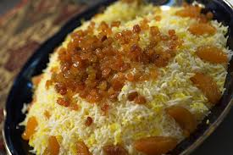
Main Course:
Traditional Baku pilaf
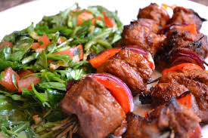
Lamb Kebab
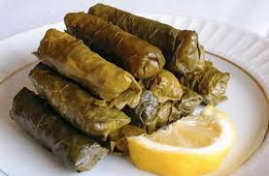
Grape leaves stuffed with lamb

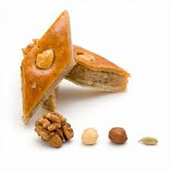
Dessert:
Baklava
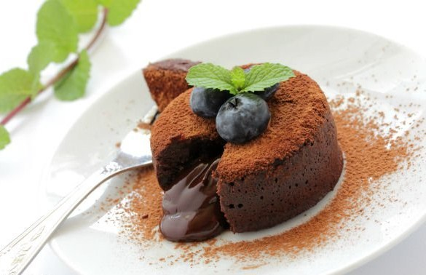
Hot chocolate cake with ice-cream

Drinks:
All kinds of drinks

