Magomedova Amina

We are going to celebrate my sister’s birthday in February, as it is in winter the party will take place indoors. So, I decided to begin with salads continued with the main dishes, and by the end the guests will be served the desserts, hot and cold drinks are included.

Menu
Salads:

- Caesar salad
- Salad nicoise
- Russian salad

Main dishes:

- Pizzas
- Chicken in a creamy sauce with fried potatoes
- Salmon with grilled shrimps and vegetables

Desserts:
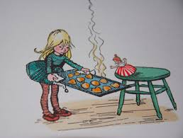
- Birthday cake with nuts
- Blueberry cupcakes
- Chocolate muffins

Drinks:

- Milk/ Banana Cocktails
- Lemonade
- Berry tea

