The weirdest things in Russia which could shock a foreigner

If you are an inveterate globe-trotter this information will most definitely be helpful for you. No matter how experienced you are in travelling or how open-minded you are, when you leave your own country you could feel disorientated and furthermore experience culture shock. So these are some unusual things you could potentially face while being in Russia. The following hints will help you to adjust to the unfamiliar culture and to avoid feeling of depression.

- The first thing you could probably find a bit bizarre is the fact that Russian people are used to give detailed and honest answers, if they are asked about how their things are going. For a foreigner it is just a simple way to start a small talk or just a polite way of communication. However, in Russia questions like: “How are you?”, “How is it going?” implies sincere interest in one’s life and people do not hesitate to answer it in great detail.
- Another interesting and maybe unusual thing is that Russian people do not smile to strangers. They do not smile to people with whom they accidently meet eyes. That is why foreigners tend to believe that Russians are gloomy and unfriendly, which is a common stereotype. In fact, Russian people are the nicest and most helpful people, you could possibly meet, you should just get to know them a little bit better.
- Another part of Russian culture that may frustrate foreigners is the way Russian people celebrate New Year's Day. In fact, the Russians do it in a greater scope than Christmas. It is quite well-known that New Year is the main winter holiday in Russia. Just take a look: Christmas tree - for the New Year, gifts - for the New Year, sparklers and fireworks - for the New Year. In contrast, Christmas is celebrated by a much smaller number of people and is much more modest.
- On top of everything, another thing you should know is that the Russians like to talk and eat. When they have dinner in a big company, they sit at the table, eat and talk. Then having finished the dinner, they just talk. A bit later, they eat again and talk. They drink tea after the meal and talk. Even standing at the doors, leaving home, they still keep talking. So it is in their nature to sit at the table for dinner and stay for hours until midnight or longer, constantly talking.

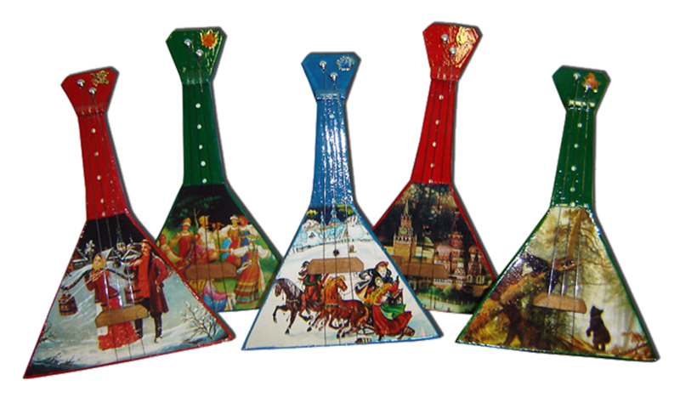
As Hans Christian Andersen said: «To travel is to live». So one cannot exist without experiencing all possible aspects of life through travelling. So hopefully baring these facts in mind would help you to speed up the process of getting over culture shock and make your journey more pleasant and enjoyable.

