Editor Toolbar - Adding Content
This section provides a basic overview of the different options for adding content to your wiki using the Editor Toolbar. It provides instructions for adding links, images, files and certain widgets. Here is a snapshot of the content buttons on the Editor Toolbar:

Inserting Images and Files
The 'File' button allows you to upload files and add them to your wiki. Images, videos, and audio files will embed directly on the wiki page while other file types will embed a link to download the file.

To insert an image:
- Place the cursor where you want the image to appear on the page
- Click 'File' button
- Click 'Upload Files' to access your images
- Select the image you want to upload
- After the image is done uploading, it will appear in the image uploader
- Click the image thumbnail to insert it on the page

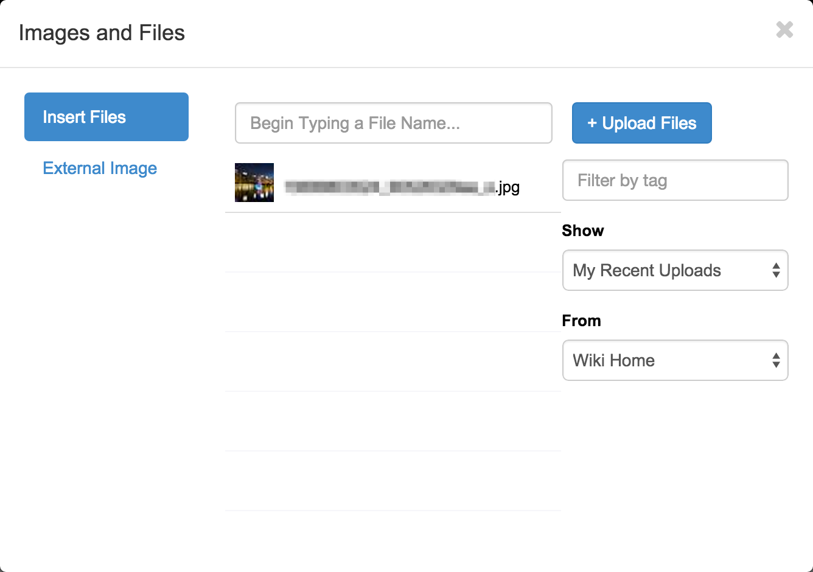

To insert an external image:
- Place the cursor where you want the image to appear on the page
- Click 'File' button
- Select the External Image tab
- Type or paste the image URL in the field-box
- Click 'Load'

To access image properties:
- Click on the image in the Visual Editor
- Choose alignment
- Resize the image
- Turn the image into a link
- Add a caption to the image

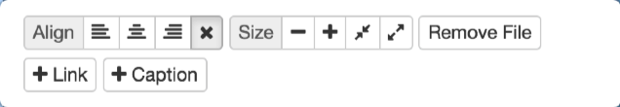

Inserting Links
The 'Link' button allows you to turn highlighted text into a link. You can link the text to a different page in your wiki, an anchor placed on a page in the wiki, or an external site.

To insert a wiki page link:
- Highlight the desired text
- Click 'Link' button
- Type the name of the page you want to link in the Page Name field-box OR select the page from the dropdown menu
- Click 'Add Link'

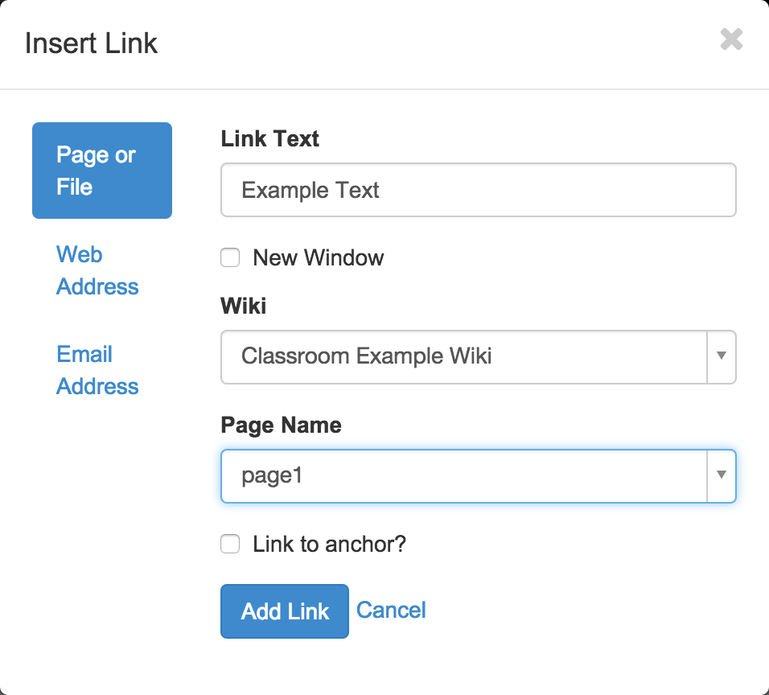

To insert a link to an external website:
- Highlight the desired text
- Click 'Link' button
- Select the Web Address tab
- Type or paste the website URL in the Address field-box
- Click 'Add Link'

