Best off-the-beaten track in South Australia
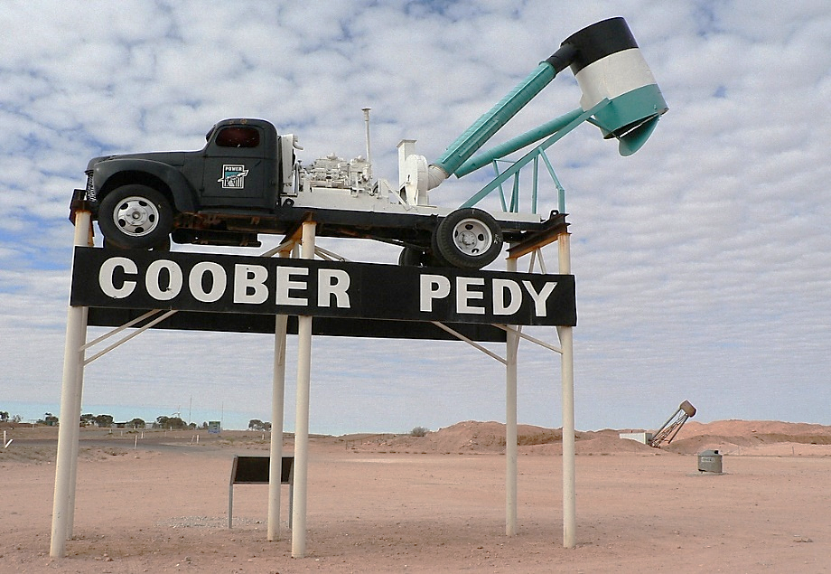
Coober Pedy is a small town in South Australia. The small town where people do keep houses - it is real – underground!
Besides, once a place for gold-seekers, these days “Coober Pedy is recognised as the largest producer of opal in the world”, that is why it is known as the Opal Capital of the World.
Why visit Coober Pedy?
You will have a chance to:
- explore a real underground world
People in this town live underground as it is extremely hot in summer (around 50˚C) and it is freezing cold in winter. Underground areas are full of life. There is an underground bar, an underground café and even underground churches, you can camp underground or book yourself a room in an underground hotel, inn or guest house. Visit Faye Naylor’s Underground Home to learn more about this kind of living.
- walk through real opal-mines and find out all about opals
In the 1960’s hundreds of Europeans came to Coober Pedy hoping to dig up a fortune. If you want to get a real learning experience, go on a tour of Coober Pedy’s opal fields that reveals heaps of debris from prospecting shafts.
- get lucky and earn a fortune
Join the Down ‘n Dirty Opal digging tour. Who knows what you might find? Apparently, a lucky visitor found themselves an opal worth $50,000.
- meet amazing story-tellers with their startling stories
The old timers have fascinating tales about their wonderful discoveries. Stories about digging out enough opal in 20 minutes to buy two houses in Melbourne are pretty common.
- enjoy strikingly beautiful landscapes
Hike to the top of the Opal Cave to watch a breathtaking sunset and then have a surreal night under the stars.
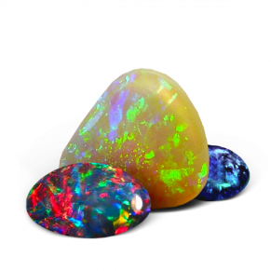
Come to Coober Pedy to get one of the most exhilarating experience of your lifetime!

