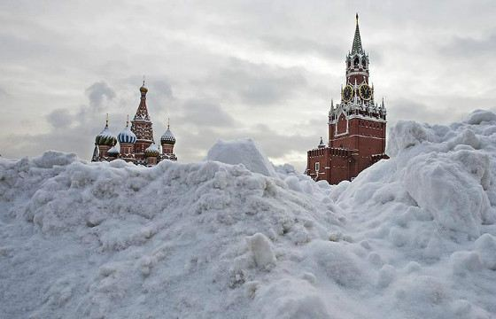
Avoid culture shock

It’s no secret that adjusting to a new country is always hard. Culture shock is unavoidable, either positive or negative one. We are going to inform you about some features of Russian culture you should be aware of while travelling and give you some advice on how you can integrate into a new environment.

Food
Don’t be surprised if the locals offer you more food than you’re able to eat, because for them it’s the way to extend their hospitality. If you’re lucky to have a dinner with Russians be ready to sit in the far gone night and leave the house with pockets full of sweets, sandwiches, pies, etc. Natives will go out of their way to make you feel welcome. Speaking about the Russian cuisine in particular, many dishes can seem to you flavourless despite its high calorific value. Also, you shouldn’t travel to Russia if you don’t like mayonnaise as it’s a necessary ingredient of many Russian dishes.

Red tape
Another thing that can lead you to culture shock is red tape. If your trip isn’t a flying visit and you have to live for some months in Russia, you should be ready to spend much time waiting for different references. Usually it’s out of the question for foreigners to waste time queueing for useful documents but it’s not alien to Russians.

Strange patriotism
As a foreigner don't allow yourself to discuss problems facing the country. You may be shocked but only natives have a right to pick holes in its political and economic system. If you say something wrong be ready that a true Russian will fly off the handle. It’s not because they don't like their country, but because they prefer to solve problems in Russia by themselves without any intervention of others.

Lack of private space
You may be surprised by the fact that Russians don’t think about private space of other people, especially in public transport. It doesn’t mean that they don’t respect you, it is just not restricted by social norms. Sometimes it’s the only way to ‘survive’ in overcrowded underground during the rush hour.

Now you have enough reasons to avoid visiting Russia but not enough to make the whole impression about the culture. If you’re a globe-trotter don’t blow your chance to get acquainted with this wonderful country. Its peculiarities are out of this world that’s why we’re sure you will get itchy feet and come back there!

