Nisyros - a volcano you can spend your holidays on!
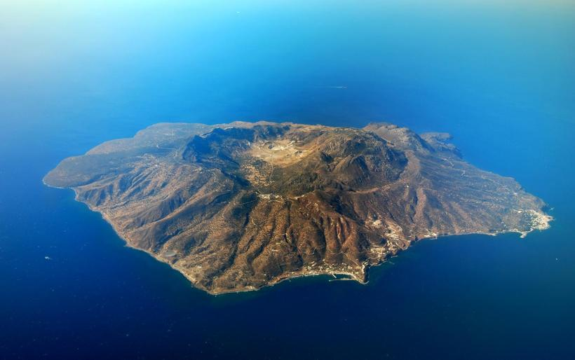
An island which is also an active volcano, you cannot wish for more for an unforgettable holiday. Nisyros is one of the most beautiful Aegean islands, still untouched by the tourism growth.
It is located in Greece right between Kos and Tilos islands. Although Nisyros seems to be off the beaten track, it is definitely worth visiting.
According to mythology, it was created during the war between Gods and Giants. Poseidon chased the Giant down to Kos, cut a part of it and threw it to his enemy, sinking him in the bottom of the Aegean Sea. The legendary rock is the modern Nisyros and it is said that the volcano’s explosions are the angry breathing of the Giant.
It is a place where you can find both solitude and energy of night life.
You сan get there by ferry from the mainland and from the nearest islands, such as Kos, Rhodos etc. You will call at the harbor and our travel agents will get you to your hotel.
Speaking about the accommodation we should mention that the best options are to rent a flat or to opt for the youth hostels. Local people will definitely welcome you with great pleasure and hospitality. Youth hostels are beneficial in terms of both price and quality. Youth hostels on Nisyros are relatively cheap, about 7-8 euros per night. Apart from the low price they provide all general hotel facilities you will ever need.
Although if you fancy something close to the all-inclusive concept you will find spa and resort hotels here as well.
As the island is small and mountainy hitch-hiking is not an option here, so you can rent a motorcycle to comfortably get around.
Apart from the volcano it has many archaeological sites and monuments. It is worth visiting the Castle, the monastery of Panagia Spiliani, the various Chapels, museums, and ancient ruins in Argos.
If all of this is interesting for you, contact our travel agent and you will be able to have a cut-price tickets for this holiday.
This place is worth visiting, as A.P. Chekhov said: “You can find everything in Greece”. And you will most definitely find your “everything” here, on Nisyros.

