A STAR JOURNEY TO FABRA OBSERVATORY IN BARCELONA!
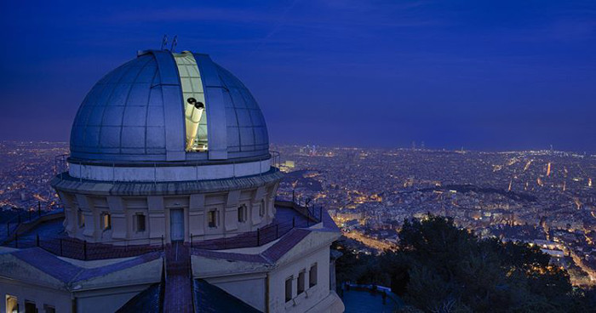
Do you want to approach the starry sky as if you were near it ? Do you like to get exhilarating experience and see rare views? Are you tired of boring museums and exhibitions? The observatory Fabra is the best option for you!
The building of observatory is located at the height of 415 meters above sea level. It gives you a special opportunity to catch sight of all Barcelona’s views. It is a great chance to enjoy the cosy atmosphere of the observatory.
What is so unusual about Fabra?It is the oldest operational observatory all over the world! It was built in 20 century and even now it is engaged in science activities in different spheres.
During the excursion best guides disclose you the secrets of the construction of the observatory ,show you two 100 years old telescopes and invite you to see the observatory platform. Moreover, you can lounge around the territory and make wonderful photos.
It is really convenient for tourists that the observatory works from morning till night every day,with the exception of several public holidays.
In this month we have special offer! After excursion you can book a table in our restaurant and taste some extraordinary dishes . Moreover , we all tired of the stresses of urban living. It is so much nicer to sleep outside under the stars .You have such an opportunity in the observatory.
If you do not want to pass over an opportunity to get to stars , call us and order the excursion! Keep on the move before a great adventure.! May be it is Fabla that you will like the most about Barcelona! Stars are waiting for you!

