How to avoid culture shock in Russia.
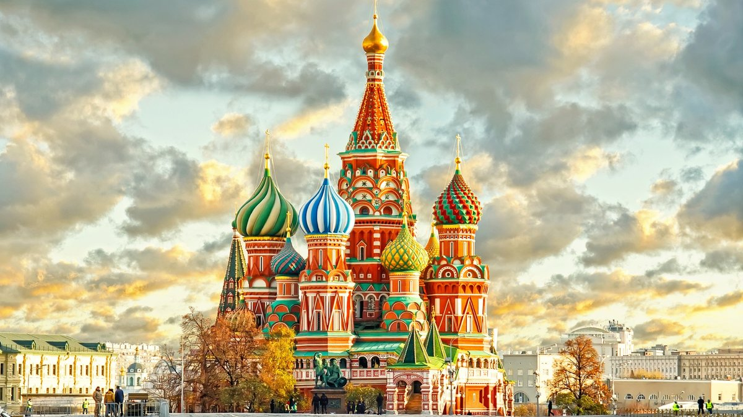
It is always terrific to travel around the world. It gives the opportunity to get the exhilarating experience and to explore the various locations. However ,after leaving your home cozy atmosphere you can face culture shock. It can happen with everybody, because the new culture is alien to us. Even open-minded and strong people are not immune to culture shock.
I want to suggest some fruitful methods ,which you should be aware of to avoid cultural shock in Russia.
Firstly, you should learn more about the district where you will live ,it reduces the feeling of uncomfortable during your trip. Moreover, you can find maps to understand what route is the most convenient to get the places you want to visit. It is because there are too many traffic jams in Russia,so you should think about how to travel around the city.
If you do not know Russian language at all , you can take several lessons to improve your skills . Not all people in Russia can speak foreign languages, that is why it can be difficult for them to help you in some situations. Learn some phrases to be sure that you will be understood.
It can be strange for foreigners ,but Russian people are not used to smile really often! They are not evil, it is simply a feature of their national character.
Stay in touch with your family and friends .Tell them all about your experience on the phone or you can skype them in the evenings to hear their voices and to be supported.
Do not be uptight! Try to connect with Russians ,even it is hard for you to speak Russian language. Try not to be alone ,because you can get the feeling of depression.
Anyway, the culture shock sounds worse than it is. If you comply with my recommendations you can speed up the process of getting over culture shock.

