YOUR MUST-SEE DESTINATION
Big Lagoon (Miniloc Island) is one of the places which you should definitely visit during your lifetime. Why? Just imagine a tropical paradise and you have this very place. There are:
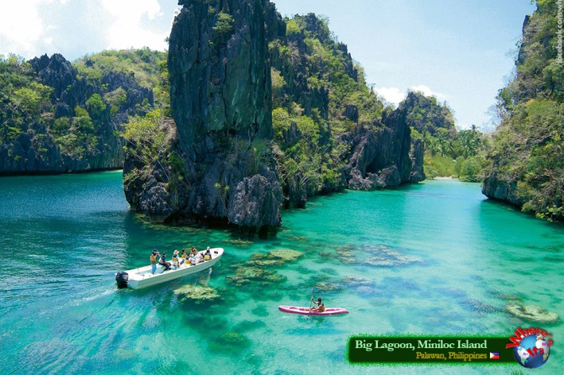
- hundreds of tiny islands
- coral reefs
- limestone cliffs
- turquoise water
- white sand beaches
- hidden lagoons

Big Lagoon is off the beaten track. It is not that easy to get there.
Unusual destination like this ensures that there are no crowds of annoying tourists and only committed ones share this trip with you.
It is easy to feel like you are the last pearson left on earth when you arrive at these islands!
There you can just drift along and enjoy marvelous landscapes. For example, it is possible to rent a kayak to reach the islands. And it is really worth getting an exhilarating experience while exploring the hidden lagoons and beaches within many of the islets!
The best time to visit Big Lagoon is from Sepember to June. In July it rains heavily there.
There are quite a lot of different hotels with a cozy atmosphere and you will definitely find the one you can feel comfortable in.

Spend your holiday one on one with nature and you will never regret your decision.

