The last to return – the first to be seen!
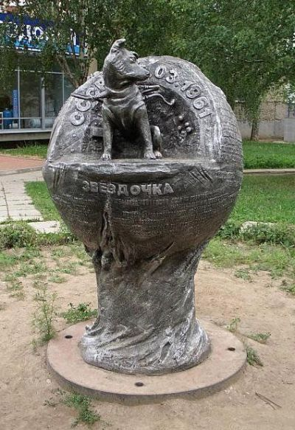
It is easy to go somewhere by a package holiday. Travel agents can choose something "special" for you, something exciting. But it is not the way we suggest you. You usually have to visit resorts or some sights during high seasons that are very popular and, logically, boring. Be brave and change established views on travelling by travelling off the beaten track! Visit the monument devoted to the last dog flown to space and remained alive —Zvyozdochka!

The monument is situated in Udmurtia region, in the city called Izhevsk. You may ask us is it really worth visiting? The monument is so small and the town is so far away. But go there and get a real learning experience!
The story of the monument is wonderful! Shortly before the flight of Yuri Gagarin into space, the dog Zvezdochka was sent. She got involved into the first space task by the same way as all the other dogs - from the street. At first Zvezdochka was given the nickname-Luck. Her space name was changed before the start: Gagarin and his collegues came up with a new one for her: "Cosmonauts are superstitious people. What if it's a failure? "And she was renamed to Zvezdochka.
The aircraft landed successfully near Izhevsk. And now you have a chance to touch history! May be, you think that it is too far away, you have to get there by train or a sheduled flight, the trip is long, etc. But it is a chance to be your own boss! Choose time, go as you please, choose your own accommodation (you can find any in the city: a small inn, full board, halhf board, etc.), but you should see it! More over, you don't have to spend a fortune on entrance fees because it's absolutely free.
It is important to know that on the sculpture you will see the history of the dog-cosmonaut and names of specialists (declassified for the first time ) who paved the way into space. The text is duplicated on the Braille alphabet (for blind people).
Do you still have any doubts? Don`t be afraid of an exhilarating historic experience and get away from it all! Small things are usually more important. See one of the national heroes who is not very well-known. Travel; see beautiful Izhevsk, study your country- the first space power! Let it be the holiday of a lifetime!

