MENU Pan-Asian style diner

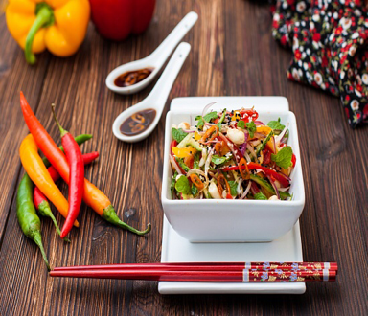 | Fresh salad in pan-Asian style  Fresh vegetables (tomatoes, sweet peppers, chili peppers, celery, cucumber, salad) soy souse, lime juice, sesame seeds.
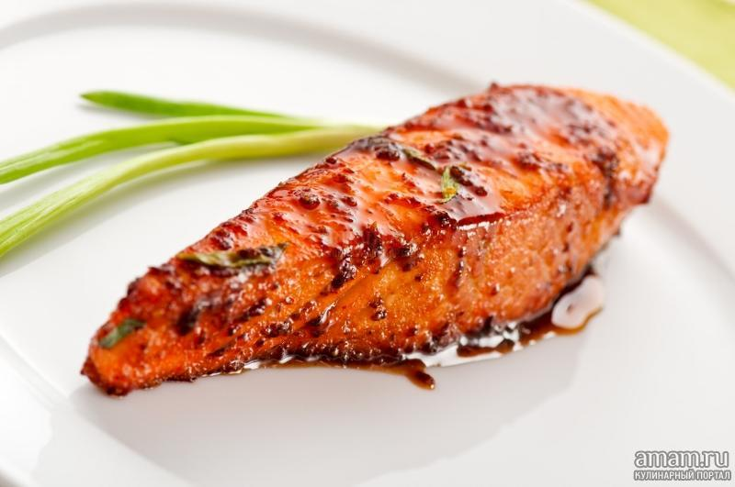 | Salmon in soy-honey sause  served with grilled vegetables and rice
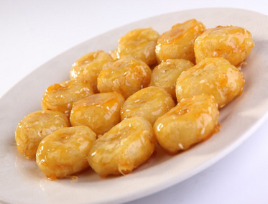 | Sweet fried bananas
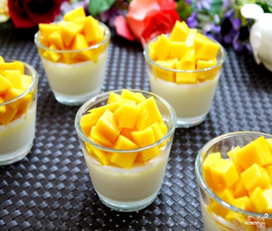 | Coconut jelly desert

