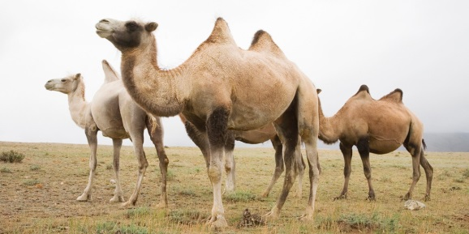
Altai is located in the southeast of Western Siberia. It is a unique land rich in mountains, numerous mountain passes and plateaus. This magnificence is surrounded by endless desert steppes. The most well-known of them is the Chuyskaya steppe, which is believed to be the driest place in Russia. And it is exactly the place where camels are bred.
Altai is renowned for its lakes – the most picturesque ones in Russia, though it is doubtful that any person would dare swimming in its ice-cold waters. Only Lake Aya and a few more are warm enough for people. There is also one lake in Altai called Dead Lake - will find neither fish nor plants in it.
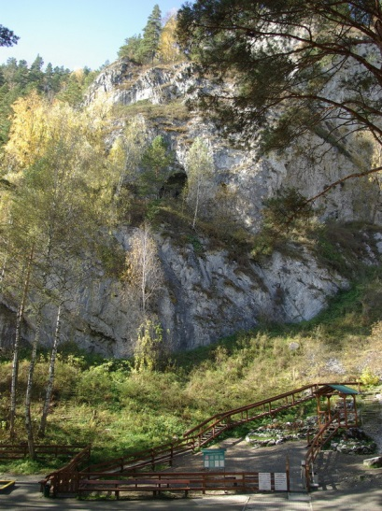
The rivers of Altai are as legendary as its mountains. They roar in the narrow canyons, and calmly flow spreading wider and wider on the open space of the steppes. White, foamy, rich in rapids and rifts, they make an impression of boiling water. For all this Altai Rivers are so much appreciated by the lovers of rafting.
In the Altai Mountains there are lots of caves and grottos. There is a whole complex of tangled underpasses where you may always find something unusual and interesting. Most of the caves can be visited without any special preparations, while others are not to be entered alone as it may be fatally dangerous.
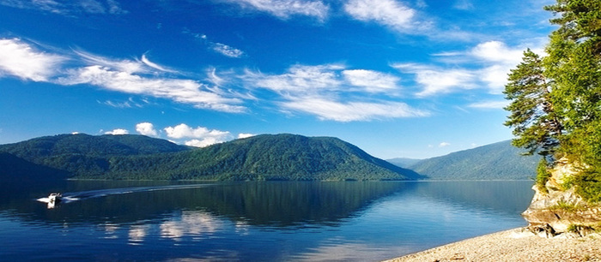
Altai is a region with pleasant climate and enchanting wild nature. And no wonder, that Altai with its lakes, mountains and rivers which take you breath away when you look at them, and the wide range of sport activities possible there, is the best place to visit for the people throughout the world.

